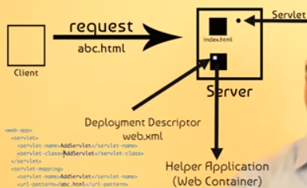

* Takes the request
* Processes the information
* Send the response

We need to use service method in servlet.

We use 2 objects.HTTPservletrequest and HTTPservletresponse object which are created by tomcat.

.HTTPservletrequest-to get request from client.

HTTPservletresponse-to get response from client

<http://localhost:8081/demotypeservlet/add?num1=5&num2=10>

The highlighted portion is query string which passes data from client to server

Web.xml is the deployment descriptor where we give different configurations there can be different servlets in a application,so a servlet name is given

<servlet-class> -give the servlet class name

<url-pattern> -give the form action

res.getWriter() – returns an object of print writer

when <form action=*"add"* method=*"get"*>

the url is <http://localhost:8081/demotypeservlet/add?num1=5&num2=10>

when <form action=*"add"* method=*"post"*>

the url ishttp://localhost:8081/demotypeservlet/add

find the code in F:/slambook/demotypeservlet

// use of dopost..it will work only when post is present in form action

<form action="add" method="post"> when ,method=”get ” is given it throws a error in webpage

Tomcat will call get service method in HTTPservlet,which will call do get or do post as needed

// use of doget..it will work only when get is present in form action

<form action="add" method="post"> will throw an error

Call servlet from a servlet:

1. Request dispatcher-is a interface

RequestDispatcher rd=req.getRequestDispatcher("sq"); //searches in web.xml for servlet mapping for sq

rd.forward(req, resp);

in the http servlet(calling) ,pass the attribute using req.setAttribute("k", k);

in the sqservlet(called),get the attribute using int k=(int)req.getAttribute("k");

Lifecycle:

Request object is one which holds the values

Send redirect:

Will send different object to servlet1 and servlet2

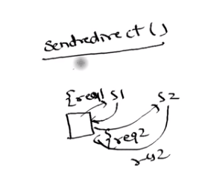

1. Send Redirect:

In Addservlet: resp.sendRedirect("sq?k="+k); //send redirect to send value

In sq servlet: int k=Integer.parseInt(req.getParameter("k"));

The above method of passing value is called URL rewriting

Passing values in session:

Session is given by tomcat

In addservlet;

HttpSession ses=req.getSession();

ses.setAttribute("k", k);

resp.sendRedirect("sq");

In sqservlet:

HttpSession ses=req.getSession();

**int** k=(**int**)ses.getAttribute("k");

k=k*k;

The data will present in the session throughout unless it is deleted

Passing using cookie

In add servlet

Cookie cookie=**new** Cookie("k", k+"");

resp.addCookie(cookie);

resp.sendRedirect("sq")

in sq servlet:

Cookie cookie[]=req.getCookies(); //returns an array of cookie

**int** k=0;

**for** (Cookie cookie2 : cookie)

{

**if**(cookie2.getName().equals("k")) //provides the expected vaue

k=Integer.*parseInt*(cookie2.getValue());

}

Instead of XML we can use annotation based:comment the XMl

@WebServlet("/add")

**public** **class** Addservlet **extends** HttpServlet

@WebServlet("/sq")

**public** **class** Sqservlet **extends** HttpServlet